**1. Write a C program to add two integers.**

**Input:**

#include <stdio.h>

void main()

{

int a, b, sum;

printf("Enter two integers: ");

scanf("%d %d", &a, &b);

sum = a + b;

printf("Sum = %d\n", sum);

return ;

}

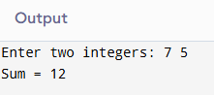

**2.** **Write a program to swap two numbers using a temporary variable.**

**Input:**

#include <stdio.h>

void main()

{

int a, b, temp;

printf("Enter two numbers: ");

scanf("%d %d", &a, &b);

temp = a; a = b; b = temp;

printf("After swapping: a = %d, b = %d\n", a, b);

return ;

}

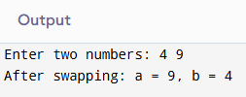

**3.** **Write a program to swap two numbers without using a temporary variable.**

**Input:**

#include <stdio.h>

void main()

{

printf("Enter two numbers: ");

scanf("%d %d", &a, &b);

a = a + b;

b = a - b;

a = a - b;

printf("After swapping: a = %d, b = %d\n", a, b);

return ;

}

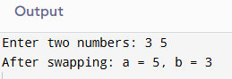

**4.** **Write a program to find the ASCII value of a character.**

**Input:**

#include <stdio.h>

void main()

{

char ch;

printf("Enter a character: ");

scanf(" %c", &ch);

printf("ASCII value of %c is %d\n", ch, ch);

return ;

}

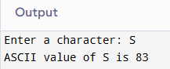

**5.** **Write a program to calculate the area and perimeter of a rectangle.**

**Input:**

#include <stdio.h>

void main()

{

float perimeter, area, width, and length;

printf("Enter width and length: ");

scanf("%f %f", &length, &width);

area = length * width; perimeter = 2 * (length + width);

printf("Area = %.2f, Perimeter = %.2f\n", area, perimeter);

return ;

}

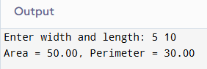

**6.** **Write a program to compute the simple interest.**

**Input:**

#include <stdio.h>

void main()

{

float principal, rate, time, and interest;

printf("Enter principal, rate, and time: ");

scanf("%f %f %f", &principal, &rate, &time);

interest = (principal * rate * time) / 100;

("Simple Interest = %.2f\n", interest);

return ;

}

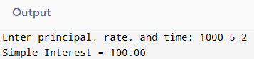

**7.** **Write a program to convert temperature from Celsius to Fahrenheit.**

**Input:**

#include <stdio.h>

 void main()

{

float fahrenheit, celsius;

printf("Please input temperature in Celsius: ");

scanf("%f", &celsius);

fahrenheit = celsius * 9/5 + 32;

printf("Temperature in Fahrenheit = %.2f\n", fahrenheit);

return ;

 }

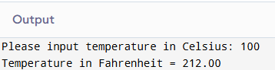

**8.** **Write a program to find the quotient and remainder of two integers.**

**Input:**

#include <stdio.h>

void main()

{

int dividend, divisor, quotient, remainder;

printf("Enter dividend and divisor: ");

scanf("%d %d", &dividend, &divisor);

quotient = dividend / divisor; remainder = dividend % divisor;

printf("Quotient = %d, Remainder = %d\n", quotient, remainder);

return ;

}

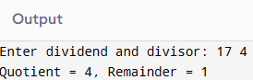

**9. Write a program to check whether a number is even or odd.**

**Input:**

#include <stdio.h>

int main()

{

int num;

printf("Enter an integer: ");

scanf("%d", &num);

if (num % 2 == 0)

printf("Even\n");

else

printf("Odd\n");

return ;

}

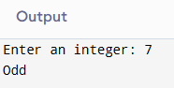

**10.** **Write a program to calculate the square and cube of a number.**

**Input:**

#include <stdio.h>

void main()

{

int num, square, cube;

printf("Enter a number: ");

scanf("%d", &num); square = num * num; cube = num * num * num;

printf("Square = %d, Cube = %d\n", square, cube);

return ;

}

